

Search

David Murphy

26 July [Development](https://messapps.com/tag/development/)

**Setting Up Your First Project with Android Studio**

## Setting up Android’s IDE and creating your first sample project

***NOTE*** *Before moving on to the guide, keep in mind that 2GB is the minimum disk space required to download and install Android Studio ­ 4GB is what we recommend. Android Studio requires a compatible version of the JDK (Java Development Kit). Unless you’ve recently been coding through Java, chances are you don’t have JDK pre­installed.*

## [Click here and visit Oracle’s website to download the version that matches the platform you’re device currently running off of.](http://www.oracle.com/technetwork/java/javase/downloads/jdk8-downloads-2133151.html)

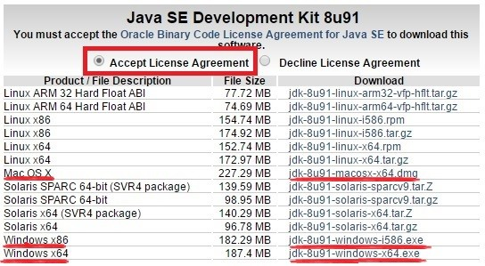

***NOTE*** Make sure you’ve filled in the bubble highlighted above

Once downloaded, proceed through the setup until you see the following

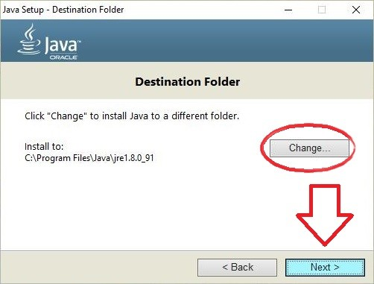

Either remember the predetermined path or change it to a more prefered location: you’ll need to know where to access these files later on

## After successfully installing the newest version of JDK, cilck here and visit Android’s development website to begin downloading Android Studio

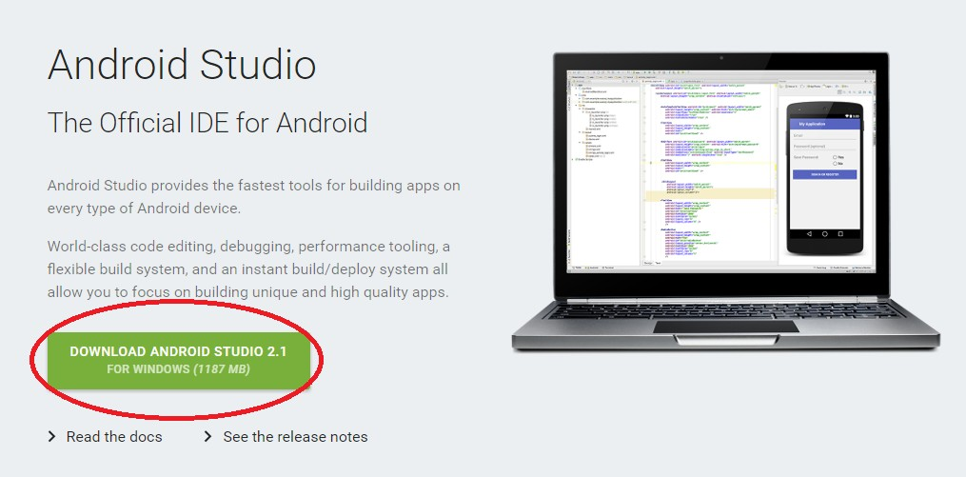

***NOTE*** This method of installation is compatible with both iOS and Windows devices

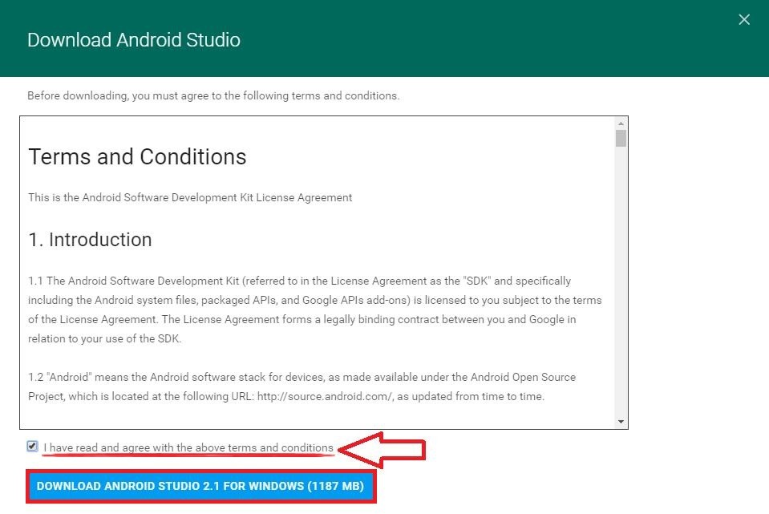

The download will begin shortly. If done correctly, a prompt should appear at the bottom­left corner of your browser.

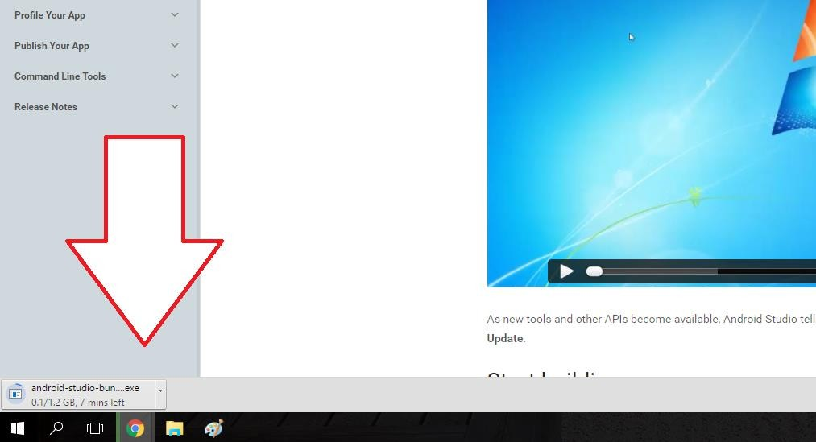

Once downloaded, click the prompt indicated above. Then, click **YES** on the following window that asks for permission/access to your files. Proceed with the download, making amendments wherever you see fit. After thumbing through several optimization screens, your final installation should be complete

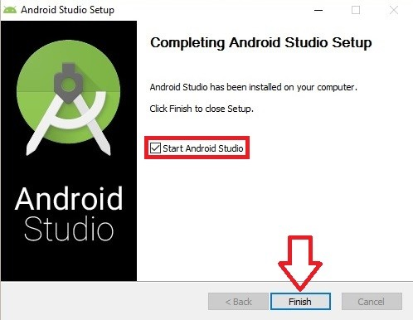

***NOTE*** You may be required to manually locate and set the path to the JDK files that you downloaded at the beginning of this guide

### *Welcome to Android Studio!*

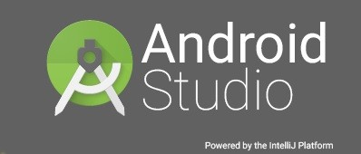

***Navigating the Setup Wizard…***

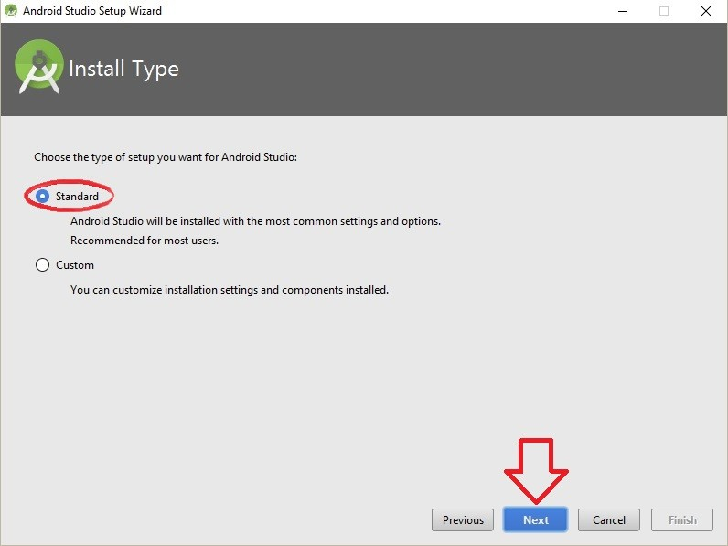

Make sure **Standard** is selected and hit **Next.** On the next screen, click **Finish** and wait for the Wizard to complete

### *Setting up your first project…*

If it isn’t already, open up Android Studio and click on the first prompt to **Start a new Android Studio project**

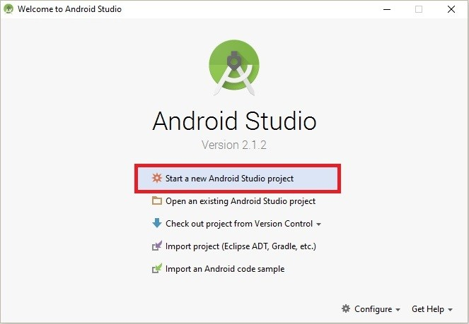

The next upcoming window will ask you to input three of the following specifications: **­ Application Name** is the name that users will see. For now, **label it “Sample Project”**

* **Company Domain** affects not only the Package Name of this project but also the following projects to come. Android Studio remembers the Company Domain and appends each package name with whatever you submit. **Leave this blank or default for now**

* **Project Location** is the where this and every other subsequent project will be stored

­ The **Package Name** is the way your project will be identified, and the name is a combination of both your Application Name, Company Domain, and Project Location. However, it can be **Edited** independently from the Application Name and Company Domain

Your screen should look similar to this:

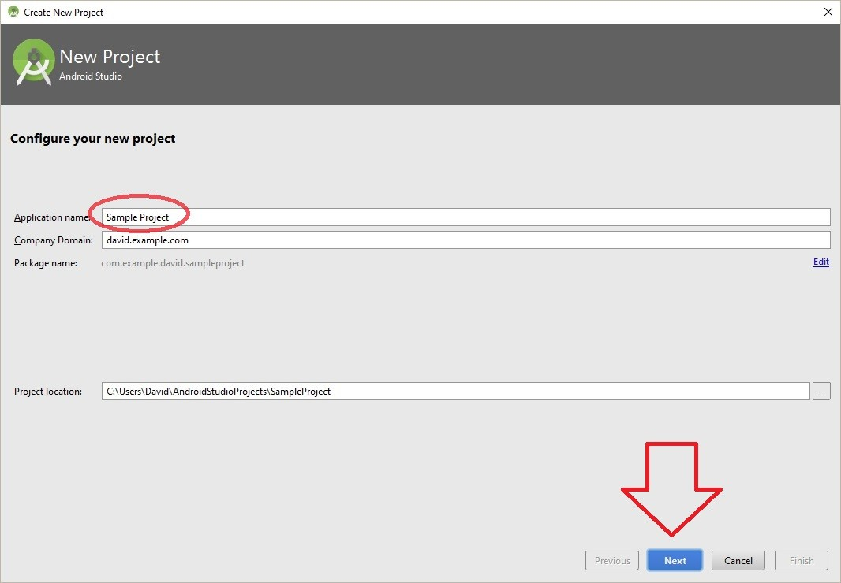

We’ll be focusing on **Phone and Tablets**, so scan the image below and make sure to exclude all other platforms. **Selecting API 8: Android 2.2 (Froyo)** beside **“Minimum SDK”** will ensure that your app is compatible with **100% of devices** that are currently active across the Google Play Store

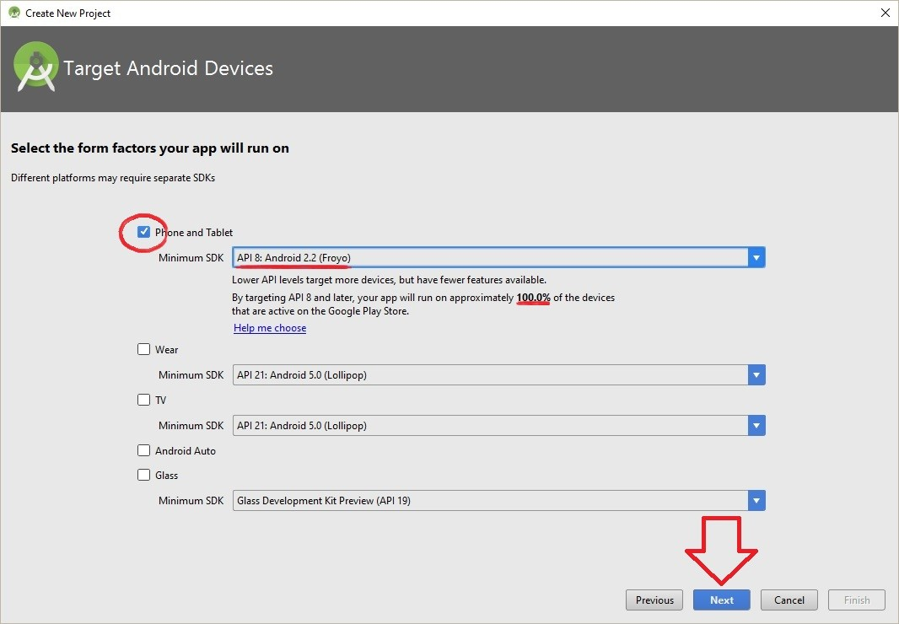

After clicking **Next**, select the **Basic Activity** template and click **Next** again

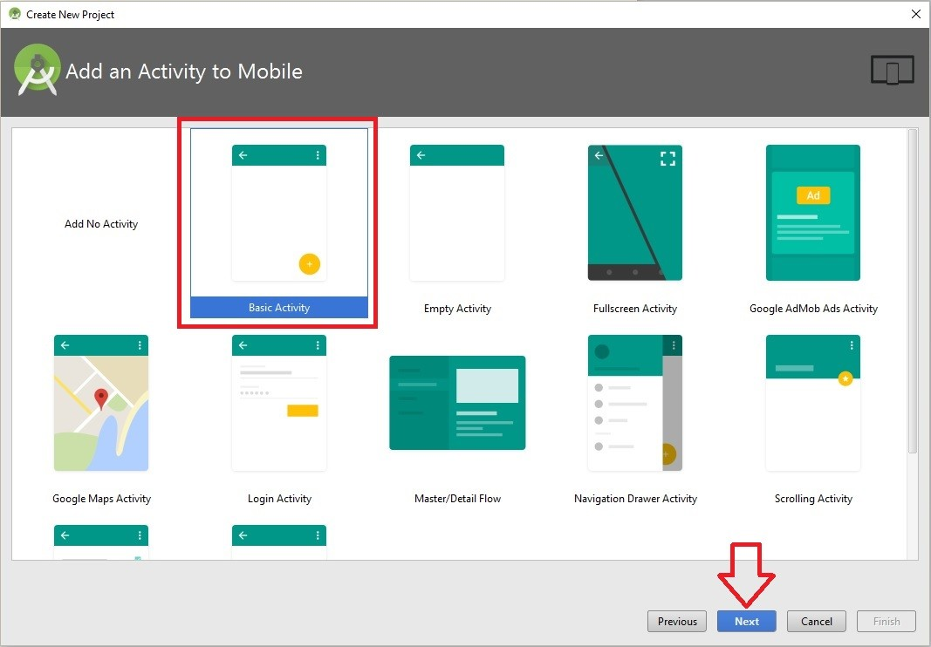

Change the **Activity Name** to *My Activity*. Both the **Layout Name, Title** and **Menu Resource Name** should change automatically

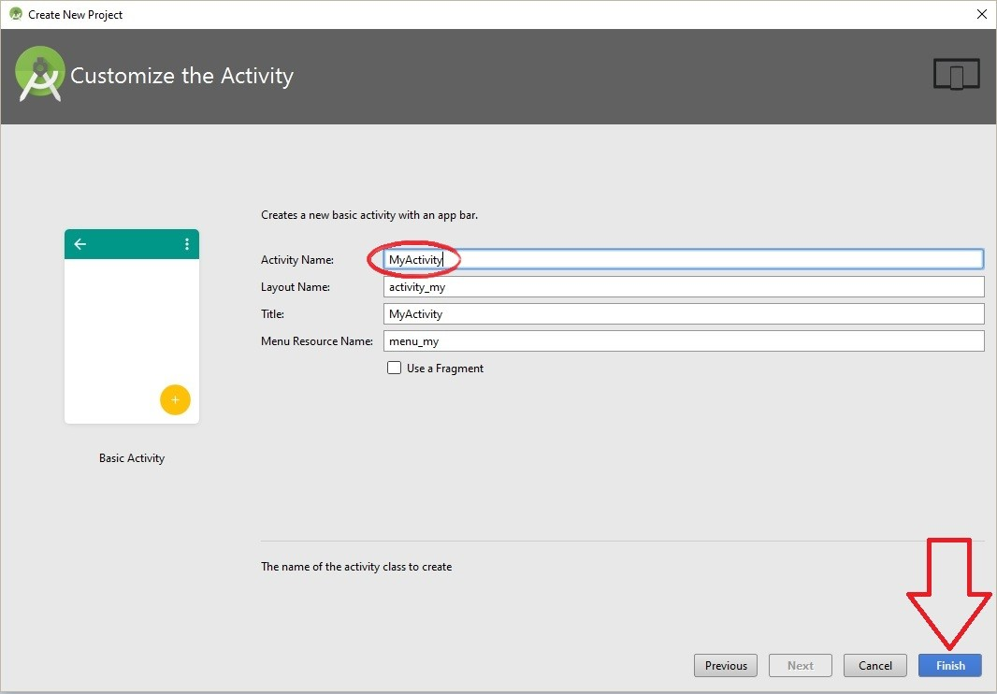

After clicking **Finish**, Java will request access to your files yet again; click **Allow**. Upon initial installation, Android Studio needs to unpack a sizeable amount of data; the UI might need some time before fully deploying. If this is the case, don’t exit App Studio. Find the loading bar located at the bottom/bottom right­hand corner and wait until its completion before continuing any further.

Otherwise, this concludes our guide on getting started with Android Studio!

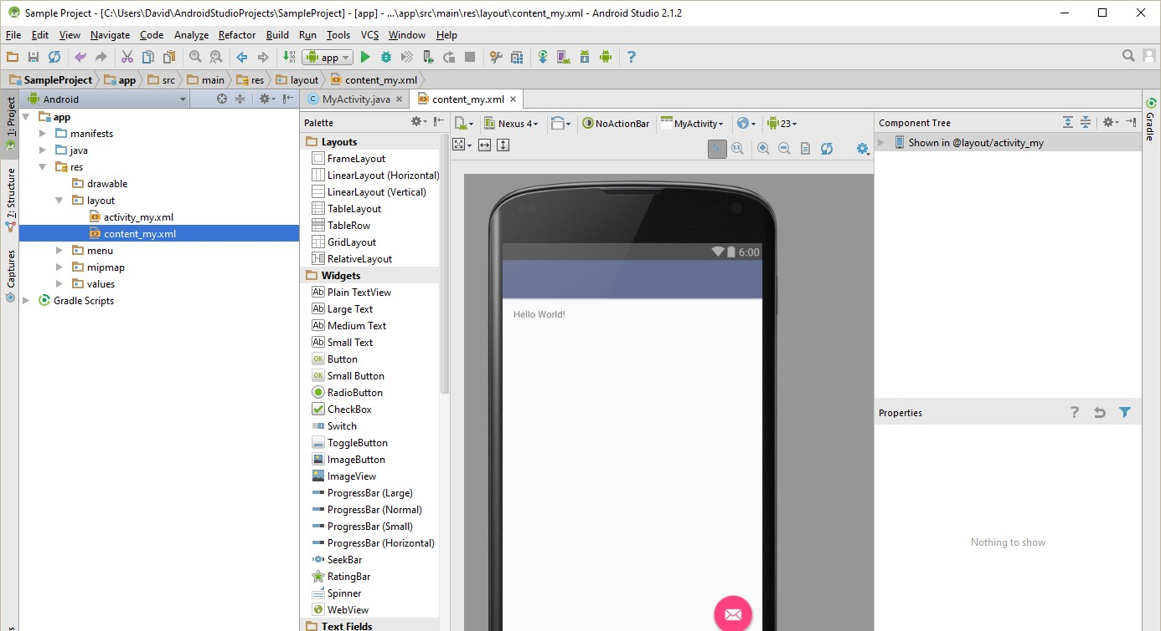

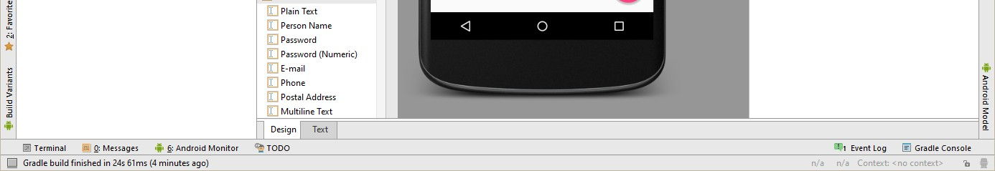

0

You might also like this articles

Dominick Wojtas



27 June

# [5 Qualities of a Successful Mobile App](https://messapps.com/academy/articles/5-qualities-successful-mobile-app/)

Not since the dot com days has there been such flock of technology startups. Success stories such as Instagram and Twitter have tantalized peoples palates to go follow in their footsteps. But with the increasing number of apps present in the app stores (1.6 million in the Google Play store, 2 million in the Apple app store as of June 2016) the competition is high.

0

Dominick Wojtas

22 June

# [Using Social Media For Your App](https://messapps.com/academy/articles/using-social-media-app/)

Social media is running unrestrained through the streets of the 21st century, and as a creator of an app, you need to harness it and take control. With seemingly everyone you meet a part of some form of social media, it is an important marketing strategy for your app to be a part of social media as well.

0